

WinVinaya Foundation is an NGO which trains persons with disabilities, women, and economically weaker section in industry aligned skills.

WinVinaya is partnered with Inclusive Schools, Colleges/ Universities to address the skill gap in Foundational Skills like English Communication, Java, Financial Accounting, Power BI and ,more. ​

As part of the EduConnect Project, which was funded by Accenture we connected with 4 colleges ​-

* National Institute of Speech and Hearing ( NISH), Trivandrum​
* Centre for Differently Abled Persons ( CDAP), Trichy​
* SRN Adarsh college, Bengaluru​
* TEACH, Mumbai​

Last year, WinVinaya collaborated with Top MNCs like Wells Fargo and Unilever to conduct targeted placement drives. In addition, based on the candidate’s interest of amplifying the social impact, WinVinaya recruited persons with disabilities as its trainers as well.

Given below are case stories of 4 candidates who are leading a life with dignity.

**Case Story: Danish's Inspiring Journey**

Danish's story is one of resilience, determination, and continuous growth. Despite facing challenges early in life, Danish pursued his passion for learning and sports with unwavering determination.

Born and raised in Thiruvananthapuram, Danish's journey took an unexpected turn when he lost his hearing due to a fever at an early age. However, this setback did not deter him from pursuing his dreams. Danish's love for sports, particularly Table Tennis, Chess, and Cricket, propelled him to excel at the state level, earning him accolades and recognition.

Driven by his passion for technology, Danish pursued a bachelor’s degree in computer science from the prestigious National Institute of Speech and Hearing (NISH). Despite his hearing impairment, Danish's dedication and enthusiasm shone through in his academic pursuits.

Embracing the opportunity for personal and professional growth, Danish enrolled in the IT Full Stack training program offered by the WinVinaya Foundation. Alongside technical training, Danish actively participated in English and Soft Skill sessions, recognizing their importance in today's competitive job market.

Throughout the training program, Danish demonstrated exceptional focus, attentiveness, and a thirst for knowledge. He eagerly embraced new concepts aligned with current industry trends and generously shared his expertise with classmates facing challenges. Danish's quick learning ability and proactive approach set him apart, earning him admiration from peers and trainers alike.

Danish's efforts bore fruit when he secured an internship opportunity at Unilever, a testament to his dedication and perseverance. Even as an intern, Danish continued to push himself, consistently striving for excellence and upskilling to stay ahead in his field.

Today, Danish stands as a proud employee at Unilever, having successfully transitioned from an intern to a valued team member. His journey serves as a shining example of the power of determination, resilience, and continuous learning in overcoming obstacles and achieving success.

**Case Story: Marimuthu's Journey**

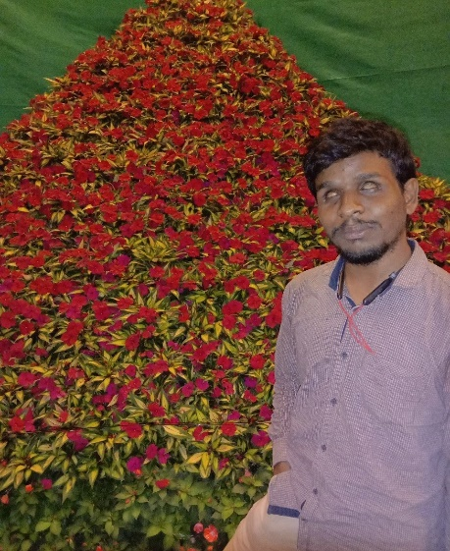Marimuthu is a highly accomplished individual with visual impairment, having completed his M.A. and earned a diploma in Computer Science. His journey began amidst the challenges of living with visual impairment and being raised by his grandparents. Despite these obstacles, Marimuthu's determination led him to connect with the visually impaired community at the age of 9.

School presented its own set of challenges, with Marimuthu being the only student with a disability, struggling to grasp even basic concepts like Braille. However, his life took a positive turn when he joined an inclusive school in the 5th grade. Here, he immersed himself in Braille and various subjects, connecting with a supportive community of visually impaired individuals. Through his hard work and dedication, Marimuthu became the sole family member to earn a master's degree while living with a disability.

Guided by supportive mentors, Marimuthu seized the opportunity to join WinVinaya’s Accessibility Testing training program. His determination led him to an even greater role as a WinVinaya trainer, where he empowers visually impaired children by training them in digital skills, helping them excel in exams, and nurturing their self-reliance. As of now, he has trained 100+ candidates in digital skills, conducted disability sensitization sessions in major events, and supporting his family with his income.

Marimuthu embodies the spirit of a "go-getter," ceaselessly pursuing his dreams and making a significant impact on WinVinaya. His contributions to training and Accessibility testing have played a crucial role in achieving several milestones for the organization.

**Case Story: Anakha Suresh's Journey**

 Anakha Suresh's journey is a testament to resilience, determination, and the transformative power of support and opportunity. Born with a hearing impairment in Trivandrum, Anakha was raised by her mother and grandfather and she navigated life with courage and strength.

Anakha's journey took a significant turn when she pursued her graduation in B. Com from the National Institute of Speech and Hearing (NISH). Despite her disability, Anakha's perseverance, coupled with the assistance of a surgically implanted internal processor and speech therapy, enabled her to communicate and hear to some extent.

Tragedy struck Anakha's life with the loss of her mother, leaving her devastated. However, she channelled her grief into focus, immersing herself in the training provided by WinVinaya Foundation. Initially, online training posed challenges as she juggled coursework and training, but Anakha quickly adapted and found the sessions engaging and enriching.

Anakha credits WinVinaya's dedicated trainers for their sincere efforts in ensuring her understanding through interactive sessions. The online training equipped her with a better understanding of Financial Accounting, Banking, and MS Office. In addition to that the offline training at WinVinaya especially in interview preparation through mock interviews, expert sessions, and soft skills development, honed her skills even further.

Armed with a newfound confidence, Anakha embarked on her career journey, securing a position as the **Associate Loan Servicing Representative** at Wells Fargo. While adjusting to the work culture presented initial challenges, the post-placement support provided by WinVinaya proved invaluable. With their guidance, Anakha seamlessly integrated into her role and is now excelling in her job.

Anakha's story exemplifies the triumph of perseverance over adversity and the impact of holistic support in empowering individuals to realize their full potential. Through her journey, she embodies the ethos of resilience and serves as an inspiration to all.

We wish her all the best in her future endeavours. ​

**Case Story: Ananthu Krishnan's Inspirational Journey**

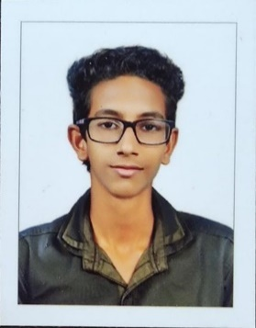 Hailing from the vibrant city of Thiruvananthapuram in Kerala, Ananthu Krishnan's journey is a testament to resilience and determination in the face of adversity. Born with Hearing and Speech Impairment, Ananthu's early years were marked by challenges that he courageously overcame.

Ananthu's educational pursuit led him to the prestigious National Institute of Speech and Hearing (NISH), where he pursued his passion for learning, completing his graduation in B.Com. Supported by a loving family comprising his mother, a devoted housewife, and his father, an Ex-serviceman, Ananthu's journey was fuelled by their unwavering encouragement.

Ananthu's affinity for sports, particularly Table Tennis and Cricket, provided him with moments of joy and triumph, including a notable achievement of securing the 3rd place in Table Tennis Doubles within the state of Kerala.

In his final year of B.Com, Ananthu embraced a new opportunity by enrolling in online classes offered by the WinVinaya Foundation. The interactive nature of the sessions, coupled with hands-on practice, provided Ananthu with a deeper understanding of the subject matter and boosted his confidence. The practical insights gained through the training equipped him with the skills necessary to navigate real-world challenges.

With newfound confidence and skills, Ananthu embarked on a professional journey, securing a position as the **Associate Loan Servicing Representative** at Wells Fargo, a significant milestone in his career. Despite initial adjustments to the corporate environment, Ananthu's resilience and determination, coupled with the support he received from WinVinaya, paved the way for his success.

Ananthu's story serves as an inspiration to all, demonstrating the transformative power of perseverance, support, and self-belief in overcoming obstacles and achieving one's dreams.